The Benefice of Harton

The Circular

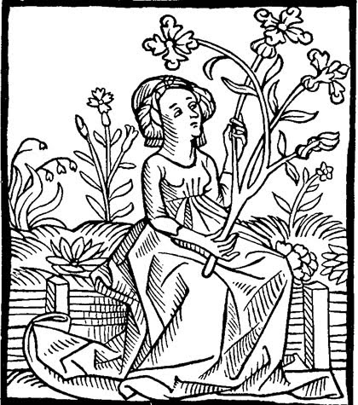

Spring edition 2014

February March April

Sand Hutton Claxton Flaxton
Gate Helmsley Upper Helmsley Bossall
Buttercrambe Howsham Harton
Whitwell-on-the-Hill Crambe Foston
Barton-le-Willows Thornton-le-Clay

Services for the Benefice of Harton

Important Note: The Benefice Eucharist Service on 2nd February will be held at Sand Hutton and not at Howsham as printed in the previous Circular

February
Sunday 2nd February Candlemas

10.30 Benefice Eucharist Sand Hutton

Wednesday 5th February
10.00 Holy Communion Buttercrambe

9.00 Holy Communion Bossall
Sunday 9th February 4 Before Lent
10.30 Morning Prayer Upper Helmsley

Wednesday 12th February
10.00 Holy Communion Howsham

10.30 Benefice Eucharist Flaxton
Sunday 16th February 3 Before Lent

Wednesday 19th February
10.00 Holy Communion Foston

Sunday 23rd February 2 Before Lent
10.30 Morning Prayer Gate Helmsley

Wednesday 26th February
10.00 Holy Communion Crambe

March
Sunday 2nd March 1 Before Lent

10.30 Benefice Eucharist Whitwell

Wednesday 5th March Ash Wednesday
7.00 Holy Communion Buttercrambe
10.30 Holy Communion Sand Hutton
Sunday 9th March Lent 1

Wednesday 12th March
10.00 Holy Communion Upper Helmsley

Sunday 16th March Lent 2
10.30 Benefice Eucharist Howsham

Wednesday 19th March
10.00 Holy Communion Whitwell

Sunday 23rd March Lent 3
9.00 Morning Prayer Foston
10.30 Holy Communion Buttercrambe
Wednesday 26th March
10.00 Holy Communion Gate Helmsley
Sunday 30th March Mothering Sunday
10.30 Benefice Eucharist Crambe
4.00 pm Family Service Flaxton

April

Wednesday 2nd April
10.00 Holy Communion Howsham

10.30 Benefice Eucharist Foston
Sunday 6th April Passion Sunday

Wednesday 9th April
7.30 pm Institution Service Bossall
Conducted by the Archbishop of York

10.30 Benefice Eucharist Upper Helmsley
Sunday 13th April Palm Sunday

Wednesday 16th April
No service
Thursday 17th April Maundy Thursday
7.00 pm Holy Communion Flaxton

Friday 18th April Good Friday
2.00 pm An Hour at the Cross Sand Hutton
Sunday 20th April Easter Day
10.30 Benefice Eucharist Bossall

Wednesday 23rd April
10.00 Holy Communion Gate Helmsley

Sunday 27th April Easter 2
9.00 Holy Communion Howsham
10.30 Morning Prayer Crambe

Wednesday 30th April
10.00 Holy Communion Foston

May

Sunday 4th May Easter 3
10.30 Benefice Eucharist Gate Helmsley

Wednesday 7th May
10.00 Holy Communion Whitwell
Sunday 11th May Easter 4

9.00 Holy Communion` Sand Hutton
10.30 Family Service Flaxton

Wednesday 14th May
10.00 Holy Communion Upper Helmsley
Sunday 18th May Easter 5
10.30 Benefice Eucharist Buttercrambe

Wednesday 21st May
10.00 Holy Communion Bossall

Welcome to those newly baptised

26th October Ava May Taylor Bossall
15th December Samuel Joseph Cole Crambe

Congratulations and good wishes to those who were married recently
12th October Robert McClean and Emma Thomson Buttercrambe

Our condolences to the families and friends of

8th October, John Rawling Sand Hutton
22nd October Aurelia Zastawniak-Thomas Bossall
6th December, Lorraine Elizabeth Holmes Sand Hutton
11th December Margaret Mary Clark Crambe
31st December Roland Hobbs Howsham
31st December Holgate Illingworth Bossall

___________________________________________

My Dear Friends,

A Very Happy New Year to you all!

Originating from my days spent in a Monastic Community, each day I take a simple “thought for the day” to keep my focus throughout my waking hours on God and those things that truly matter in life. It is an amazing exercise; you should try it, if you want your heavenly Father to be central in your life.

It could be a verse from the Psalms that fit every experience of life. Or a favourite hymn which could quietly lead you to God. A piece of Scripture, perhaps words from Jesus himself. Or even something you have read elsewhere. If you find it hard at first, persevere until your day is permeated with that quiet confidence in the one who only wants what is best for you, day by day.

Over the run-up to Christmas and during the Holy Season, I have been focussing on a little book by Francois Vayne, “Fifteen days of prayer with St Bernadette of Lourdes”, that amazing saint who teaches us that you don’t have to be clever, rich, prosperous, good looking or anything else to live close to God day by day. A particular phrase in the text caught my eye, “Silently, awaiting God, no matter where I find myself”.

During the Christmas season, we have all had some wonderful services in our churches, carol services, nativity plays, Christingle, and family communions.

On the whole our Benefice Services are good, mostly well supported, and I think we have all appreciated the words from our visiting preachers during interregnum. But one thing is lacking; for most of us church is social, I know that, but primarily we come into the House of God to meet face to face with our Creator. I am now writing to ask you all to take time, as you enter God’s House of Prayer, and before our services begin, to reflect on why you have come, who you are to meet in the Sacrament. “The one who comes is God”. We should kneel or sit before him in adoration and contemplation, preparing for our worship and allowing our hearts and souls to be still and quiet in readiness for the one who comes to us.

Leave your meeting up with friends and neighbours for after the service. There is always time and space for sharing, often over a cup of tea. We will over the next few months have a silent five minutes before our services begin, wherever they may be. Let us see if we can do this and so enrich our worship, our lives and the life of our Church Family.

May God bless you all. With my love and prayers as we go forward together on our journey of faith,

Your loving Sister,

Margaret Ann +CSPH on behalf of the Ministry Team

A note from the Joint PCC………………………..

The news from the Joint PCC this quarter is most welcome and quite exciting. Following a day of interviews on 28th October 2013, the Reverend Chris Wingfield has accepted the invitation to become Rector of the Benefice of Harton. Chris’s Institution Service will be held on the evening of Wednesday 9th April, so that he will be in harness in time for Easter, one of the most important Christian festivals.

We are very much looking forward to welcoming Chris and his wife, Thelma, into our community, and we ask God’s blessing on their new ministry. You can find out more about Chris and Thelma – as well as Alfie the dog - in the following piece.

The message from the Ministry Team this time comes from Sister Margaret Ann. I hope that, at the start of this New Year, we can all take note of Sister’s plea for us to become a little more contemplative in our approach to church services.

The next meeting of the Joint PCC will be on Tuesday 14th January. There is quite an extensive agenda for discussion – planning for the Institution Service, financial matters (including parish contributions to the central benefice fund, which is used for benefice expenses) and contemplation before church services.

I take this opportunity to wish all parishioners a happy and blessed new year.

Delyth Harran
Lay Chairman

______________________________________________________

The service of Institution
of Revd. Chris Wingfield
as Rector to the Benefice of Harton
will take place in Bossall church
at 7.30pm on Wednesday 9th April
led by the Archbishop of York, Dr John Sentamu

Light refreshments will be available after the service at Bossall Hall when there will be an opportunity to meet Chris and his wife Thelma.
All parishioners are invited to attend

From our new Rector…………………..

Greetings,

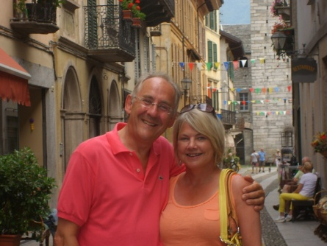Just a few words to say how delighted Thelma, ‘Alfie’ and I are to come and live in the Harton Benefice. Yorkshire is a part of the world that Thelma and I have come to know and love, as we have an aunt who lives in Helmsley and a son who lives and works in Hull. Alfie, on the other hand knows nothing about Yorkshire – but we’re fairly confident he’ll settle in very quickly!

Thelma and I were brought up in Kent, have been married for nearly thirty years and have two sons, Richard and Ben. Richard lives and works in London, is a barrister and now works for The Equal Rights Trust. Ben graduated from Hull and now works for Cranswick.

Thelma, like me, started work in Banking and Finance, but as the children got older, worked in Volunteer Management and Training for a variety of Charities (Age UK, British Red Cross, Prostate cancer, Stroke Assoc. etc.) and has recently left St Richard’s Hospice as a Project Manager for their new Community Service.

I started life in international banking and recruitment too, but a calling to the ministry led me on a different path into the Church of England. My Catholic roots, combined with Thelma’s Evangelical upbringing led to some very interesting and challenging debates in our family…. but thankfully it helped shape me into the priest I am today.

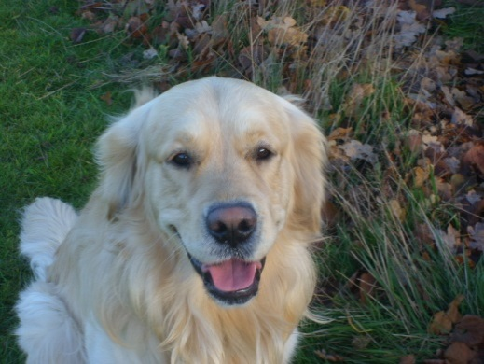We’ve moved around as a family and have lived in Kent, Oxford, Suffolk and Worcestershire, to mention a few. We’ve always had dogs – usually Labradors, but when our very elderly Sam and Harry passed away within a year of each other we thought we’d have a Golden Retriever. So we now have Alfie who is will be two years old in May. I daresay you’ll be seeing quite a lot of him in my travels around the parishes!

So there we are, just a brief few words before we arrive. Thelma and I both enjoy walking (for me, especially around a golf course) and entertaining. We’re looking forward to exploring this part of Yorkshire and hopefully discovering new friends and places.

In the meantime, we both wish you a Happy New Year and (all three of us) look forward to meeting you over the coming weeks and months.

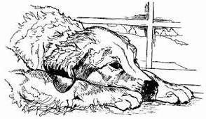With very best wishes,

Chris, Thelma and Alfie

___________________________________________________________

All you need to know about……………………….
setting up for Holy Communion
and other interesting matters

Sister Margaret Ann has agreed to do another two sessions on setting up the altar for communion, including the significance of the different coloured altar cloths and other liturgical matters.

You can join Sister for half an hour on one of the following dates:

Tuesday 18th February at 7.00 pm at St Botolph’s, Bossall
Tuesday 4th March at 7.00 pm at St Mary’s, Gate Helmsley

These sessions are open to anyone who is interested and will be especially valuable for churchwardens and other church officers.

“FOOD FOR THOUGHT”
A LENT COURSE is to be held in Saville Street Methodist Church Malton on Wednesdays March 12th – April 9th incl. At 7.30pm.

The theme looks at various aspects of food – its production and its distribution, including some theological and ethical views.

All are invited – just come along!
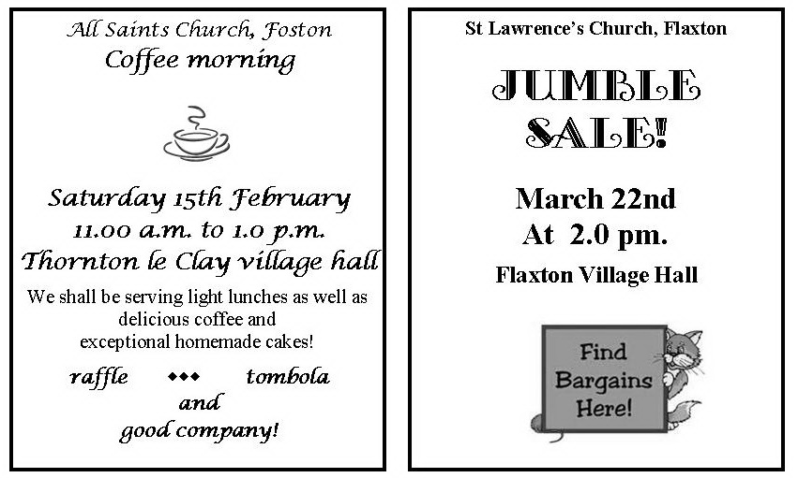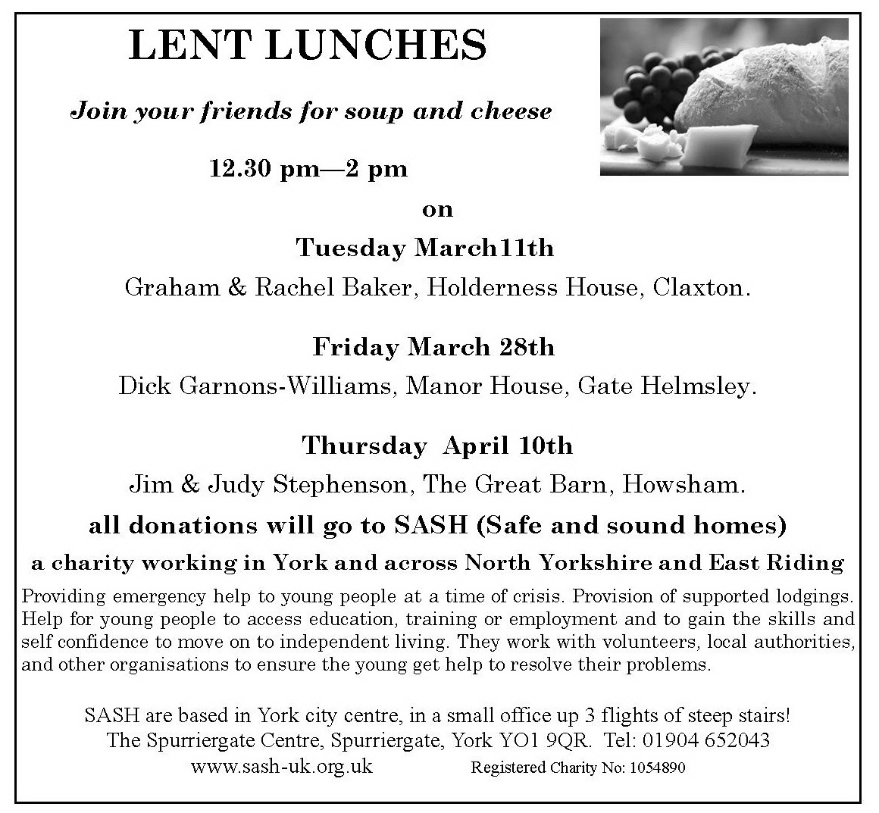
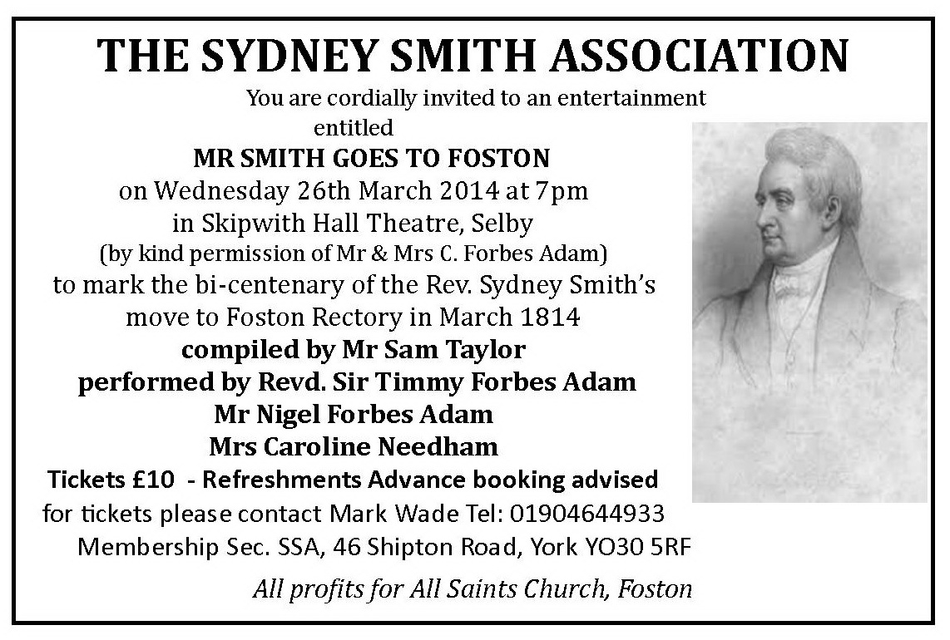
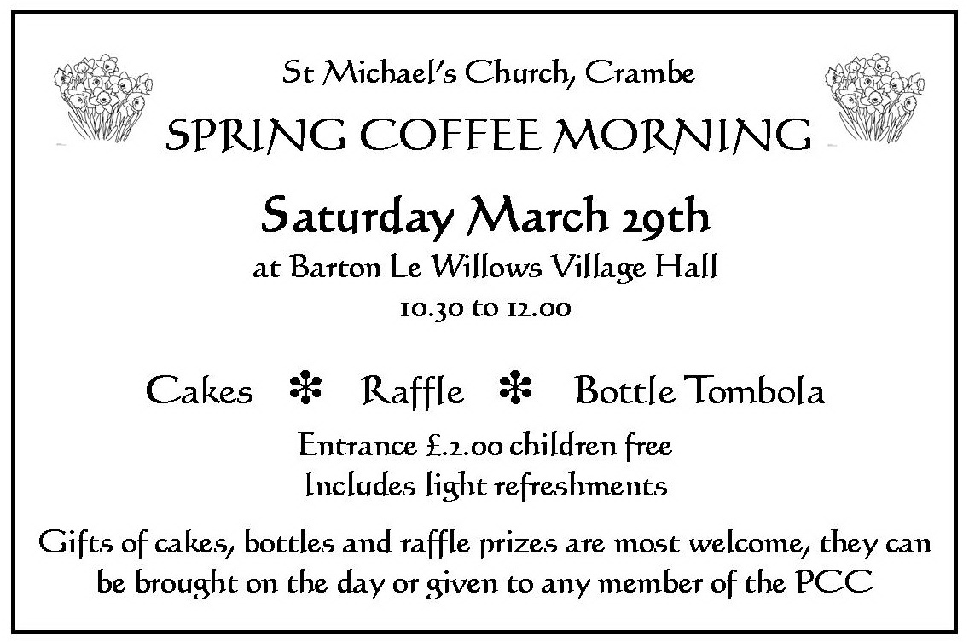

Sand Hutton and Claxton Village Hall
Forthcoming Events

Friday 21 March Pub Night: a new idea – come and meet your friends over a pint;
play darts and enjoy a quiz

Date tbc Film Night

Saturday 12 April Saturday Social

And don’t forget, the Hall is open every Monday morning between
10 am and noon, so call in for a cup of coffee and browse in the library. You can also join us for a walk starting from the Hall at 9.30am any Monday, come rain or shine.

For further information on events,
see the parish website www.claxton-sandhutton.org.uk
or contact Caroline Hall 468376 email clm.hall@virgin.net
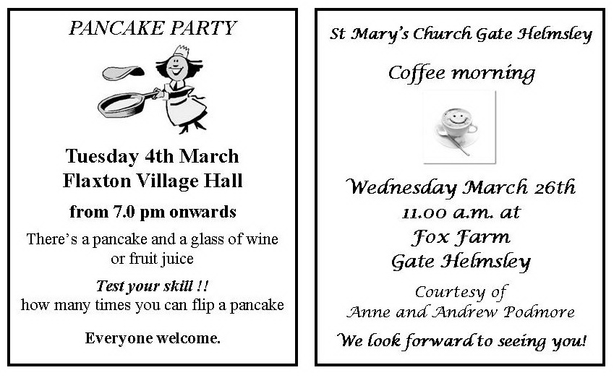
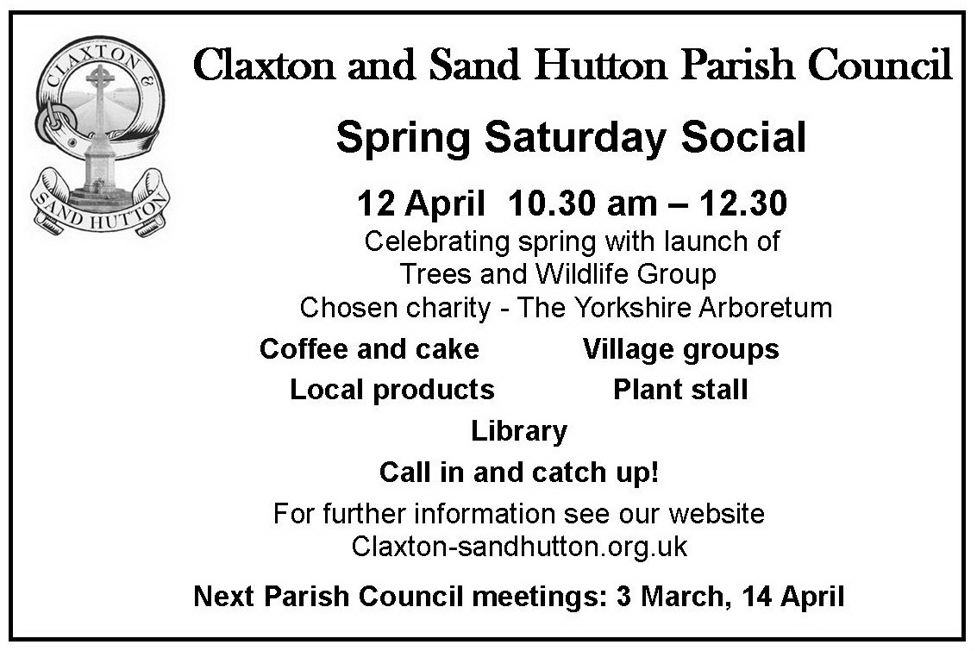

GREEN FINGERTIPS

The Gardening Club of Claxton, Sand Hutton and District

WINTER PROGRAMME 2014

All talks commence at 7.30 p.m. in Sand Hutton and Claxton Village Hall. Please arrive beforehand for a chat before the programme begins.

6 February, Peter Williams “Wonderful Weeds”
Have you ever wondered why weeds thrive despite your best efforts to kill them, while cherished plants die even though you cosset them?
This talk looks at the amazing strategies for survival that weeds use in their battle against the gardener.

6 March, Alison Pringle “A Museum Garden through the Seasons”
Alison will use her extensive and experienced background as the Head Gardener of Cragside, and now of York Museum Gardens, to describe her Gardening Year.

3 April, Tony Powell, “A History of Architecture in the Landscape”
A look at how architecture has influenced garden design through the centuries – ziggurats to mounds, Palladian bridges to grottoes, orangeries to conservatories and a lot more besides.

Visitors will be made very welcome at the small charge of
£3 per evening.
Please book in advance.

For further information please contact:-

Jane Nicoll

01653 619 149

Around the Parishes……………………………

News views and information from:

BOSSALL

You will all have noticed that the work to the boundary trees has been carried out and we have been able to sell off certain amounts but it has exposed the dreadful condition of the boundary wall which is shown to comprise stone, tiles, bricks etc. and we are having it professionally
surveyed with a view to complete restoration. We have also found a
number of gravestones just leaning against the wall and these will have
to be repositioned. More in our next bulletin!
The 'open' part of the churchyard has benefited from a second cutting and some expert attention from gardening experts which will assist in the preservation of the many and varied wild flowers and plants that we have.
On the people 'front' we record with pleasure the christening of Richard and Barbara Wood's granddaughter -Ava May Taylor- and the immaculate
condition in which the church was left afterwards.
More sombre occasions were firstly the funeral of Margaret Leeves the widow of our long standing Churchwarden - Alan Leeves, who had been an inmate at the Stamford Bridge Home but always retained a great interest in the parish and remembered us with a generous donation in her will.
The other farewell was to Holgate Illingworth who died on 30th December having been unwell for some time and whose funeral was held at Bossall. He was a long time ‘local’ and supported the Church in a number of ways
and his joviality will be missed.
Christmas Eve Midnight Mass was well attended but numbers down because other parishes had their own services that day but we had some 100 congregation and we have been able to send £180 to each of Salvation Army (Malton Branch) and to Shelterbox, our chosen overseas charity whose
work we propose to describe in a later issue of our circular.
The parish AGM has been earmarked for the evening of Mon. 10th.
March but confirmation will follow.
For any who really wish to contact Teddy Denison please note that his
e-mail address has changed to denibossall@gmail.com

CRAMBE

Sadly we have to record the death of Margaret Clark on December 12th after a long battle against illness. Margaret was a long term member of the PCC and stalwart of village life, besides being a keen gardener and talented photographer. We shall miss her down to earth common sense and offer our condolences to Peter, Janette, Susan and the family. Margaret’s funeral was held at St Michael’s on 20th December to a packed congregation. The service was conducted by Revd. Rachel Benson.

Although held at Upper Helmsley it is worth mentioning the Remembrance Sunday service. The search for a bugler proved problematic, however we eventually found the talented Gage Andrews, aged 11, from Linton on Ouse who played the Last Post and Reveille both during the service and at the Claxton War memorial later. Gage’s ambition is to play with the Black Dyke Mills band. On this showing Gage, you’re in there with a shout!
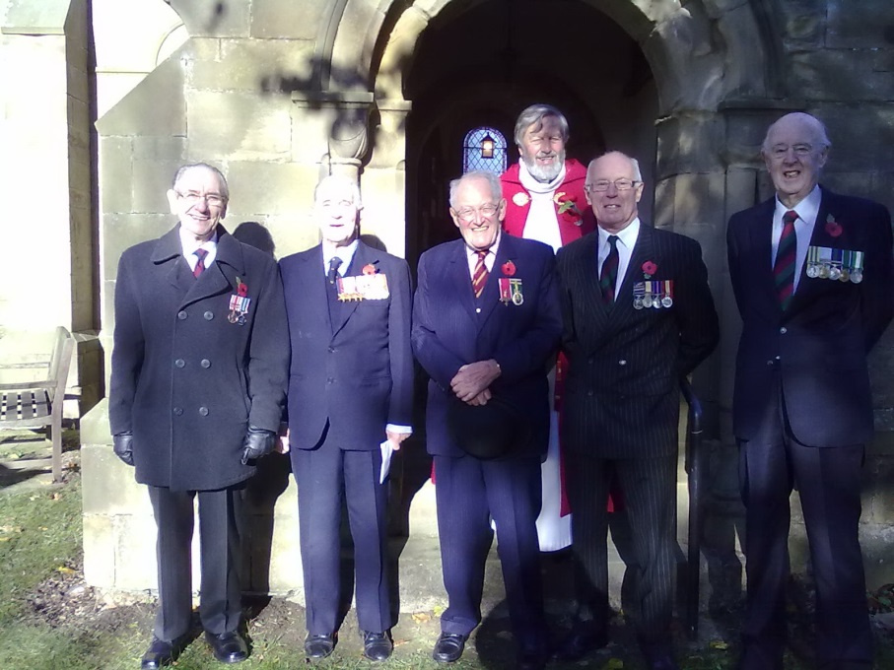

Revd. Peter Jaram
who conducted the service,
with Bryan Mills, Dick Garnons Williams, Teddy Denison, Mike Le Masurier, and a friend of Teddy’s formerly of Prince of Wales own Regiment of Yorkshire outside St Peter’s Church, Upper Helmsley

The Festival of Lilies and Light was held at St Michael’s on November 3rd at which people were invited to light candles in memory of family and friends. The church was decorated with displays of lilies.

On December 15th we celebrated Holy Communion and the Baptism of Master Sam Cole whose parents were married at St Michael’s in 2010.

Our final service in 2013 was our candlelit Celebration of Christmas in carols, poetry and prose conducted by Revd. Rachel Benson. Despite clashing with the final of Strictly Come Dancing the church was packed out. The music was provided by Peter Stott on the organ and featured solos by Rebecca Widdecombe (now a member of Gareth Malone’s new choir, ‘Voices’) and supported by her brother Charlie on the trumpet. What a way to end the year! After the service everyone repaired to Kyreham House courtesy of the Cook family for mulled wine and mince pies.

It is with great pleasure that we record the appointment of Revd. Chris Wingfield. We extend a warm welcome to Chris and Thelma. The interregnum has been a long one and has brought home what a splendid Ministry Team we have in Sister Margaret Ann, Rachel Baker and Tony Hewitt. Thanks to you all and also Lay Chairman Delyth Harran for seeing us through this difficult time, supported, as always, by our retired clergy. What would we do without you!?

FLAXTON

Thank you to everyone who supported our Book Sale and Light Lunch event in November. This was well attended and a good social occasion. Thank you to those who baked cakes, made soup, sandwich makers and to those who manned stalls and helped in the kitchen. A good team effort.

Also in November two members of the PCC were fortunate to be able to represent Flaxton at a service in Westminster Abbey to celebrate the 60th Anniversary of the National Churches Trust. Tickets were by application so we were lucky to get them. It was a very meaningful service of thanksgiving for the work the Trust has been able to achieve over the years. Readings were given by various celebrities, and 3 people from different churches were interviewed to share how they had benefited from the trust. A copy of the Order of Service is in church if you would like to know more.

Thank you to those who gave their time to decorate the church in preparation for our celebratory services leading up to Christmas. The church looked lovely and still does as I write this passage. It was delightful to see the look on the children’s faces when the Christmas tree lights were switched on at the Nativity dress rehearsal.

On 15th December we had our Nativity and Toy Service when once again the children did us proud by reminding us what Christmas is all about when they performed the story of the Nativity with group singing and a solo. Well done to you all. During the service children and adults presented gifts of toys for the Salvation Army Christmas Appeal. These were delivered the next day to the Salvation Army for which they were extremely grateful. To close the service Sister Margaret presented the children with their Sunday School prizes. The service ended with refreshments when we were able to catch up with friends who now live away but came back to support their young relatives.

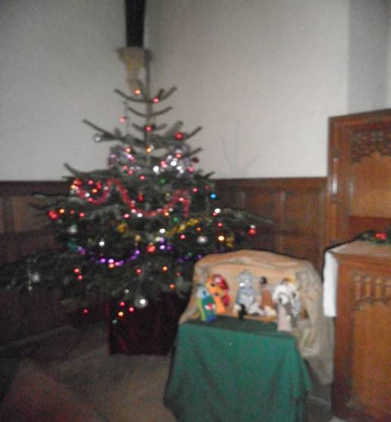In the same week we had our service of Nine Lessons and Carols and presentation of the Crib. As in previous years this was well attended (standing room only). Dick Blackford once again led the Flaxton Singers with carols old and new. A lot of hard work by everyone (not forgetting the organists) over the months leading up to the service. Thank you to each and every one for such an enjoyable evening. Also thank you to the two young people who were asked to present the crib at the last minute and to the providers of mulled wine and mince pies which we enjoyed at the end of the service.
Finally a huge thank you to those who read the Lessons.

As is tradition there will be a Pancake Party on Tuesday 4th March in the Village Hall from 7.00pm onwards. Not only will there be a pancake and a glass of wine or fruit juice to enjoy, you can also test your skill on how many times you can flip a pancake! Everyone is welcome.

Our next fund raising event will be a Jumble Sale on Saturday
22nd March at 2.00pm in the Village Hall.

FOSTON and THORNTON LE CLAY

The run up to Christmas started with one of our regular fund raising events, serving morning coffee and lunch in the Village Hall. As well as our usual goodies, we enjoyed hot roast pork sandwiches and made a satisfying £270.

Next on the menu was a very relaxed and enjoyable celebration of carols and Christmas readings by candlelight. Mulled wine on arrival helped lubricate the vocal chords.

Our Crib Service was well attended and the children were met with an amazing floodlit wooden nativity scene outside church, made by Foston resident, Nigel Tully. Many thanks Nigel, your talents are endless!

Thanks also to Celia Todd who, who this Easter will celebrate 75 years as organist at Foston. This remarkable achievement is recognised not just in our community, but in a recent article in the Church Times (see separate article)

Please join us at our next event which will be morning coffee and lunches in Thornton Le Clay Village Hall on Saturday 15th February from 11am to 1pm. As usual we will have a raffle, tombola and some good company!

GATE HELMSLEY

We have been able to fully enjoy the atmosphere of Christmas in Gate Helmsley.

The Christmas Fayre held at Orchard House on Saturday 7th December, with its mince pies and mulled wine helped to put us in a festive mood. Thank you to all those who contributed in any way to this successful event, which raised £670 for church funds.

The following Saturday, 14th December, the Gate Helmsley Village Christmas celebrations opened with a session of carol singing in St Mary’s church. We were very pleased to have the church so full, with all the singers in excellent voice. Sister Margaret Ann reminded us of the true meaning of Christmas, and some of the children helped Sister to place the Nativity figures in the stable as we all sang “Away in a Manger”.

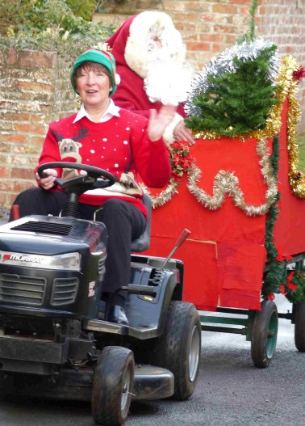An excellent Christmas lunch was served at the Duke of York, with a welcome visit from Santa and his Elf. Santa’s sleigh was a sight to behold, as you can see from the photographs. The day ended with an evening barbecue prepared by Keith Potts and his helpers. Music was provided by the local band, “Uncut”. Thank you to everyone who worked hard to make this event so memorable, especially to Dee Hillier for the hospitality of the Duke of York.

We were pleased to welcome the Reverend Dr Gavin Wakefield, Diocesan Director of Training, to conduct our Family Communion service on Christmas morning. We again had a full church, with people of all ages in the congregation. Many stayed behind after the service to enjoy coffee, mince pies and a chat.
On Wednesday 26th March from 11.00 am. Anne and Andrew Podmore will host a coffee morning at their home, Fox Farm, in aid of church funds. The Wednesday service of Holy Communion that day will be at St Mary’s church at 10.00 am.

We have two more events planned for the summer, a Strawberry Lunch in late June, and a Garden Party at the Manor House, courtesy of Captain Dick Garnons Williams. Look out for details about these events in the next Circular.

The Annual Meeting of St Mary’s PCC will be held at Fox Farm at
7.30 pm on Tuesday 29th April.

“Pipe Up!”

St Mary’s, Gate Helmsley Centenary Organ Restoration Fund

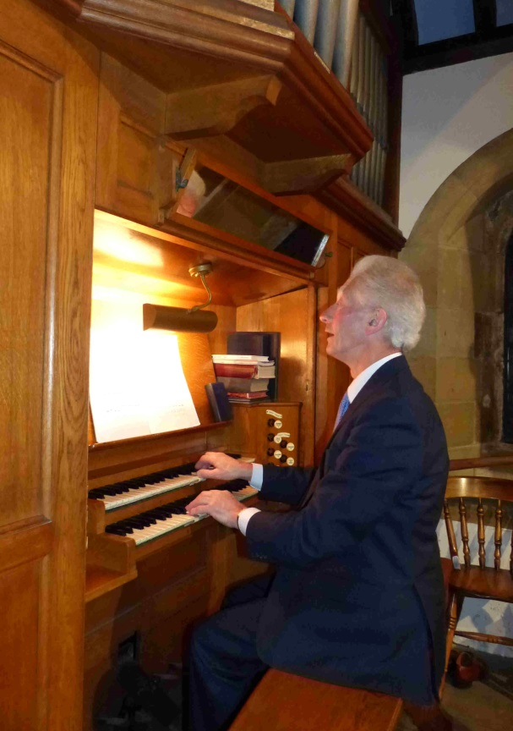

At the Dedication service of the new organ in St Mary’s on November 20th 1913 the Bishop of Beverley was attended by Canon Akenhead (onetime Vicar of Sand Hutton) and Mr H Seymour Wilkinson of York gave a recital.

The centenary of this event was marked

in November 2013 by a splendid evening with Geoffrey Coffin of Principal Pipe Organs (PPO). Geoffrey gave a lively and informative talk about the construction of the organ. He showed us some of the tools and materials used over many centuries and still employed by skilled organ builders today.

Geoffrey Coffin at the centenary recital

His talk was followed by a terrific recital on the organ of a selection of pieces – old and modern – to illustrate the various stops and combinations possible. The instrument has rarely, in recent years, sounded so good! We were however given insight into the shortcomings arising from wear and tear over the last century and the need to undertake a restoration in order to prevent a continuing decline towards total collapse. Geoffrey also outlined how some modest adjustments to the tonal range of the organ would further improve its contribution to music in this historic church.

The evening raised over £500 for the Organ Fund.

Thanks to Delyth Harran, Anne Podmore and Dick Garnons Williams for refreshments.

The fund has now passed £13,000 and we are grateful to all who have contributed over the last 2½ years. The Faculty application is prepared and this means that we can begin to look to some of the potential grant-awarding bodies. Of course there is still a long way to go so please consider donating to the fund. Sponsoring pipes is a good way of doing this – with a dedication to someone special as a lasting memorial. The restoration will include a completely new rank of pipes (a “Fifteenth” – of 2´ pitch) to brighten the overall tone of the instrument. £1000 would fund this pipe rank (58 pipes) – so, how about it?!

For more information about the history of the organ,
the restoration plans or to make a donation,
contact Michael Harran – 01759 372215 or mj@mharran.freeserve.co.uk

We hope to arrange at least one other recital this year and to have a “Race Night” in the late spring, so watch out for further news – and remember that The Stamford Bridge Singers will entertain us on 27th September.

Dick Garnons Williams, Michael Harran, Andrew Podmore

HOWSHAM

We had a great cake stall and raffle at York Auction Centre on 2nd December - well worth doing, and a decent profit for Church funds. Thank you to all who helped.

Our (very early) Carol Service was well attended and followed by drinks and mince pies at the Great Barn.

The funeral of Roland Hobson was held in Church on 31st December. He had lived in the village some time ago and his grandparents farmed here and are buried in the Churchyard.

Another section of the Church boundary wall is now in need of repairs. Messrs Carr Builders from Barton-le-Willows are hoping to start as soon as possible.

There will be a Lent lunch at the Great Barn on Thursday 10th April. Everyone is welcome.

Our Bank Holiday Cake Stall on Howsham Bridge will be on Bank Holiday Monday 5th May.

We are all looking forward very much to welcoming our new vicar, Chris Wingfield and his wife, Thelma to the Benefice and are grateful to everyone who made things run so smoothly during the interregnum.

SAND HUTTON

Gifts For Christmas: This year’s event, despite the poor weather, was blessed with a record number of visitors who were able to purchase their Christmas gifts from the many varied and excellent stalls both inside and outside the village hall. We thank all those involved, over many months, behind the scenes leading up to the occasion and to those who worked tirelessly on the day organising the sales and providing an excellent selection of food and drinks for lunch. Thanks to all who contributed one way or another in raising some £2235 for the St Mary's Tower Fund to address its continuing deterioration. A special thank you to Margaret Silver returning to Sand Hutton to help in her usual kitchen role. Margaret has been a tower of strength and support within our community and for many years served on our Parochial Church Council. We wish her every happiness in her new home in Hovingham.

Benefice Carol Service: This year, again, was a memorable beginning to the Christmas season with 'Amici' singers contributing to the service. We concur with the comments of young Gabriel in the congregation who, on more than one occasion, called for more which will hopefully be Christmas 2014.

Sand Hutton School Christmas Assembly: It was a privilege to hold the end of term service where the pupils performed a most unusual but moving interpretation of the Nativity. Well done to all involved and particularly the staff who had obviously worked hard to enable the children to reach such a high standard!

Crib and Christingle Service: Once again we welcomed people of all ages to support the work of The Church of England Children's Society who aim to care for the vulnerable and needy children in our country. We are grateful to Paul Millard of Stamford Bridge for conducting the service. We wish him well as he attends the selection board for ordination this month. A sum of £238 was given, which has been forwarded to the society.
Thank you.

Claxton Carol Singing: There was no carol singing in Claxton before Christmas last year due to the weather. Only four singers and one dog turned out on a wet and windy evening so the event was abandoned. However, not deterred, prospective singers will be encouraged to take part this Christmas to raise money for Macmillan Cancer Support and keep the tradition going.
Future Events
Gift Day
Saturday May 10th at St Mary’s Church. Sand Hutton
Between 10-30 am & 2pm
Cake and Produce stall. Refreshments.

Trip to Zambia continued……

A presentation of life in Zambia including Shika's Story
Thank you to those who have and still are contributing
to help finance Shika to train as a dentist.
Friday May 30th 7pm . Venue tba
(more details in next circular)
Refreshments Admission free

News from our schools……………………

SAND HUTTON CE (VC)
PRIMARY SCHOOL

Students from St John’s University: This academic year we have been very fortunate to have welcomed three PGCE students from St John’s University to work across both Sand Hutton and Warthill CE Primary schools. Miss Esme Kelly has been working in KS2 at Warthill whilst Mr Robert Bowman and Miss Laura Richardson have been working in Class 2 at Sand Hutton, we have been lucky enough to retain Mr Bowman for a second practice in Class 3. We have also a group of St John’s University PE students in both schools, they are taking lessons with children of different ages observed by the class teachers. Their youthful energy and commitment has been a pleasure to see, whilst they would all agree that the support they have received from class teachers and other staff has been invaluable for their career development. We are committed to the training of the next generation of teachers encouraging them to follow our school’s motto ‘to be the best they can be’, no less than every child deserves.

School Council: This year’s Sand Hutton’s School Council has been hard at work. Elected members; Freddie, Mary, Liam, Josie, Ellie, Maja, Edward, Abigail and Evie all bring their ideas about what they like about the school and suggest ways it might be improved for the benefit of everyone. Their ideas often concern activities for playtimes and lunch times and impressively, how fair the rotas for jobs at lunchtimes are. Their next task is to consult with the rest of the school to design new more permanent playground markings which everyone can enjoy.

Pre-school children: We still have our regular pre-school group on a Thursday afternoon, 1.30pm to 3.00pm; there is no charge for the sessions. This is open to all children from birth to school age to come along for a fun session and a chance for parents/carers to get together.

Thank you: The PTA Christmas Fair was a lovely evening, very well supported by families and friends of the school from the communities we serve. Thank you to everyone who supported us in any way to help raise the magnificent total of £1,160.00. We will be having our next Bags2School collection on the morning of Wednesday 26th March, please bear us in mind if you are having a Spring Clean/de-clutter.

Church School Inspection (SIAMS): We would like to congratulate our sister school at Warthill on receiving an outstanding grade in their SIAMS inspection in November 2013. Sand Hutton was awarded the same grade in 2010. Part of the report states:
The school has a powerful Christian ethos of love that drives the daily lives of adults and children. Love, trust and respect underpin the relationships and create a caring Christian community in which everyone is challenged and supported to succeed. Adults are excellent role models displaying Christian values mirrored by the children. Teachers know each child as a unique individual and ensure that academic and personal needs are fully met. Behaviour is exceptional and the children readily discuss the importance of right and wrong, forgiveness and fresh start. They understand ‘it is what a person is like inside that matters’. An ethos which is shared across both our school families.

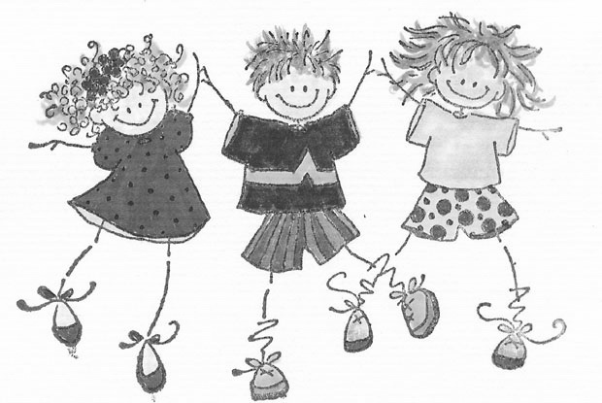FOSTON CE PRIMARY SCHOOL

Foston CE Primary School held their Christingle Service at All Saints’ Church, Foston on 20th December. The whole school also participated in ‘Pandemonium’, a pantomime on 12th December. All the children worked very hard on their singing and acting to present wonderful, entertaining performances in a packed village hall.

Earlier in the term highlights included a visit to Yorvik and The Dig by Key Stage 1 as part of their local history topic. Key Stage 2 visited Howsham Mill as part of their twinning project with Gillshill School, Hull. All the KS2 children are learning to play the violin, and they gave a small concert to children and staff on 13th December. Sporting events this term have included the children in Key Stage 1 and 2 developing their talents in multi-skills and indoor athletics tournaments at Malton Secondary School. Children in years 5 and 6 have also been developing their leadership skills as sports ambassadors.

____________________________________________

ROYAL BRITISH LEGION
POPPY APPEAL 2013

On behalf of those people whom The Royal British Legion help, may I say a big "THANK YOU" to the people of Gate Helmsley, Scoreby and environs who donated the sum of £251.36 to this year’s appeal, mainly due to the tremendous work of Mrs C Watson. Mrs Watson has decided to retire after 27 years as a Royal British Legion Poppy Appeal collector, this is a tremendous record. On behalf of the Royal British Legion, and personally, I would like to thank her for her dedication and support.
Derek White, local Poppy Appeal Organiser
Many thanks to all those people in the Flaxton & Thornton le Clay Royal British Legion District, who donated so generously to this year’s Poppy Appeal. The District total so far is £1,895.53.

This District includes many villages on both sides of the A64 between Sand Hutton and Whitwell on the Hill, and extends to Buttercrambe in the east and Bulmer in the west.

Currently there is no one to collect in Bulmer so I would be very pleased to hear of anyone who might like to volunteer to collect during the 2014 Poppy Appeal.

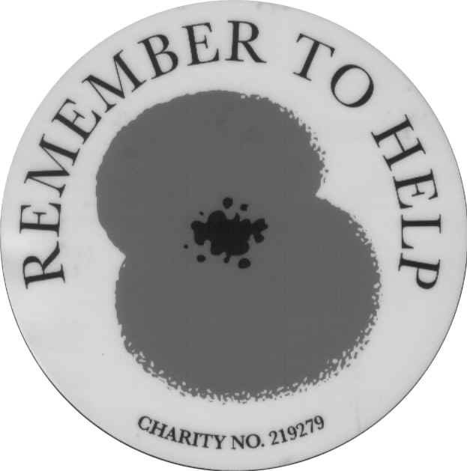On behalf of the Royal British Legion I would like to thank Margaret Dunn and her daughter Christina, who have decided to retire after collecting in Sand Hutton for 19 years, and Laura Boddy who has also decided to retire, after collecting in Whitwell on the Hill for 11 years.

Again I would be very pleased to hear from anyone who wishes to volunteer to collect in either of those villages. Your help is vital if the Royal British Legion is to continue with its valuable support of servicemen and women injured during conflict around the world.

_______________________________________________________

All about people………

Rachel Benson is familiar to most of us in her role as a vicar. Here she describes a less familiar and unusual role which she has undertaken this year.

My year as High Sheriff of North Yorkshire

It is a great privilege to be asked to be High Sheriff, and when I was approached four years ago, I had to find out just what the “job“ entailed. All I was told was that as the Queens Representative in the County for a year it would be very busy despite not including the City of York which has its own Lord Mayor and Sheriff.

The position of High Sheriff is a very ancient one, over a 1,000 years old. The first High Sheriffs being appointed by King Canute in 992 to collect the Danegold Tax. It is the oldest secular office under the Crown, Lord Lieutenants not being appointed until the mid-16th century. High Sheriffs were not popular as tax collectors, also overseeing hangings besides being the local magistrate.

The first High Sheriff in Yorkshire was William Mallett in 1069. High Sheriffs were powerful figures, just think of the Sheriff of Nottingham of Robin Hood fame! The US Sheriffs so familiar from western films have been cribbed from us. Nowadays the position is quite different, with no tax collecting or hanging! The prime job is to uphold and support law and order in the County in the widest sense. That is where my year has led me and where my interest lies. If there was to be an election the High Sheriff is returning officer.

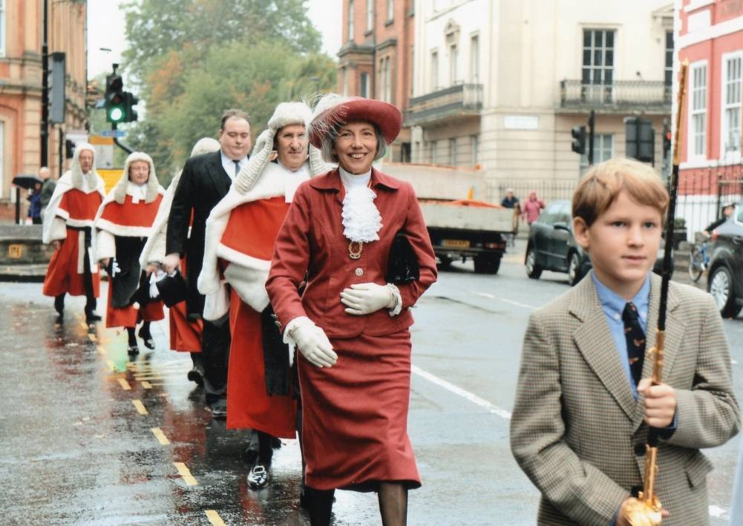I have been privileged to visit a number of prisons, and to sit in the Crown and Magistrates Courts. As I was a JP for many years I have found that very interesting as with prisons, having been involved with women offenders.

Here in North Yorkshire we do not have very many High Court judges, except for the Legal Service, which is a splendid occasion for pomp and ceremony in York Minster. This year we had Lady Hales, Deputy Chairman of the Supreme Court, the highest court in the land, several Law Lords
Marching through York with grandson and many other high Theo as sword bearer ranking judges all in their magnificent robes of scarlet and ermine. That took some entertaining, as six High Sheriffs from the neighbouring counties are involved too. Dinner parties have not been on the agenda but I have had Crown Court lunches each month, either in York or Middlesbrough

The area is enormous! North Yorkshire is the biggest county in the country and now includes Cleveland too, stretching from Scarborough to Settle and Selby to Middlesbrough. Luckily Michael gave me a sat-nav before I started, that and a good street map of the County is essential! Distances are great and I have to leave plenty of time especially if going to Harrogate!

There are Mayoral ceremonies in each district to cover, including Mayor making and charity dinners. On Yorkshire Day, I picked up Sr Margaret Ann at 7.30. We made it to Skipton just in time to board the canal cruiser which 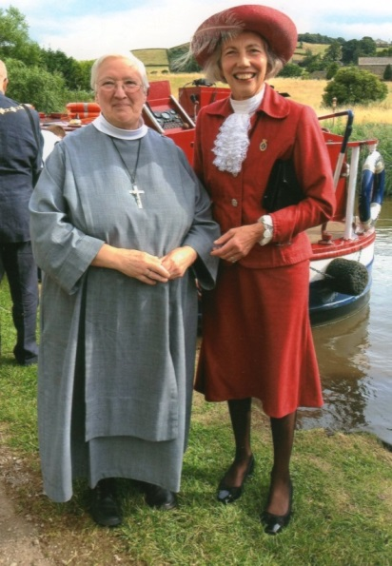took us into the middle of the town where we were greeted by the armed forces and a brass band, lined up in order and marched, or in our case walked, up the town to the church. We felt very grand with the crowds lining the streets and waving as we passed! It was an amusing and entertaining day! We had decided not to stay for lunch which started at 2pm and finished at 5pm! The weather was wonderful and hot, but a mixed blessing for the mayors sweltering in their ceremonial garb.

Part of the job is to support the emergency services and I am very impressed by the commitment and professionalism of all those I have met. Having visited the Fire Service on several occasions, I was thrilled to learn how much they do for young people and the same goes for the Armed Services and their cadets. The Police too are involved with getting young people off the streets and have a scheme called Crimebeat which encourages teenagers to explore ideas for helping their own communities. At the end of the year each scheme is judged and can go forward to national level. One such idea was to assist those entering secondary school to guard against abuse of all kinds on their mobiles. The Police have also introduced Lifestyle, a scheme where disadvantaged youngsters learn to work as a team during the summer holidays for the good of their community.

I have enjoyed visits to the Air Ambulance and to The Mountain Rescue Team up at Catterick. Both rely entirely on volunteers, and what splendid and valuable work they do. As charities they rely entirely on donations without any Government funding which of course would tie them. I believe support and encouragement of the voluntary sector and charities is important during the year as High Sheriff.

Another pleasant duty is “to meet and greet” at Royal visits. One such I attended involved literacy in schools in Middlesbrough, which has the highest level of inner city refugees in the country and where English is the second language for a very high percentage of the school children. On this occasion the Duchess of Cornwall was the Royal involved.

The High Sheriff’s year runs from the week before Easter, so this year I have three extra weeks over last year’s High Sheriff. Each visit I am invited to, or reception I take part in, I ask why it’s important to have the High Sheriff there. It is important for the recognition of the place or institution being visited. There is so much excellent work being quietly achieved, and volunteers of such high calibre who need our recognition. In my year I have given awards to the Police, made speeches, and opened two new rooms at Scarborough Hospice.

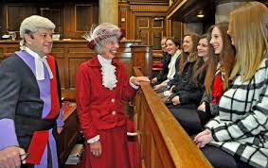One of the highlights was being able to invite 6th formers from six schools to visit the Crown Court in York. There were about 30 pupils. The Recorder, His Honour Judge Stephen Ashurst was most welcoming and told them all about court proceedings. We witnessed a mornings
Rachel ‘in court’ with 6th formers list which included the

swearing in of a jury. The visit was a great success and ended on a high note with lunch in the High Sheriff’s dining room!

In conclusion, it has been a great honour to fulfil a sort of ‘mission statement’ as the Queen’s leading volunteer, and defender of the Queen’s Peace in the County of North Yorkshire.

The next person needs no introduction as she is very well known in the Benefice! The following piece written by Sylvie Diggle, appeared in a recent edition of The Church Times.

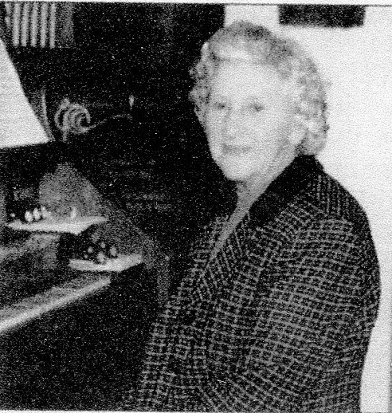She will be 93 on her coming birthday next July. Celia Todd has played the organ in All Saints church Foston for 75 years, hardly missing a single service. She has also been on the PCC for 75 years. She comes from a musical family. Her father, Thomas Fletcher Barker, owned village Farm in Foston, next to the church. It was he who gave a new graveyard to the church, and with the help of the then Rector, Canon Carr, had an Eastley organ installed in All Saints. Celia, an excellent pianist was home from boarding school, and it was arranged for her to have weekly organ lessons from Francis Jackson, the assistant organist at York Minster.

When the organist in Foston moved away, Celia took over, playing regularly at Foston as well as at four neighbouring churches, sometimes three services a day. She has been playing at Foston, ever since.

Holgate Illingworth, who died at the end of December, is less universally well-known but he led an interesting life contributing greatly to the local community in Bossall. The following is an edited version of the eulogy given by his son at his funeral.

Holgate, Holly or often simply Illingworth seems to have touched many people’s lives over the course of his 83 memorable years. Born in 1930 under the shadow of Pendle Hill in Lancashire he loved to tell of the years of robust childhood living with his four brothers and sister, going to school in clogs, milking cows and loading churns onto the dray on his way to school, and at every opportunity, missing school to spend time on the farm with his brothers.

In 1943, his father moved the family and farming operation to Birdsall and on leaving school aged 14, his working life began in earnest with the unloading of over 100 animals at Malton Station and walking them through Norton and Langton to settle them in at Manor Farm.

Work was hard with horse, human and steam power. There were Italian prisoners of war living on the farm and tanks parked on the lawn at Birsdsall. The first tractors and combines appeared on the farm soon after.

Holly married in 1960; he had to sell his chickens in order to pay for his honeymoon, his first time abroad! A new era had begun.

Holly loved his time at Birdsall but he decided at about the time his father moved to Australia, to strike out on his own and moved to High Penhowe near Burythorpe. It was not long before he took the tenancy of Mount Pleasant at Bossall. For over 50 years Holly loved and nurtured the farm and house, the village and neighbours helped by the fine and indefatigable Fred Oldfield, who became a loyal friend and colleague.

Holly was an innovative farmer during a time of great change in the industry. He was never afraid to have a go at new ideas. This manifested itself by bringing out his great skill in making things with his hands, and in some cases, being at the forefront of the development in new techniques of grain storage, farm machinery and the design of buildings to house cattle. He would disappear for nights on end into his workshop and after much bashing and clanging a new trailer, combination cultivator or hydraulic folding soil press would emerge and many would attest to the quality of the equipment he made.

From farm kit he went on to build many other great things notably a cross country riding course for the Pony Club, fences and sheds along with some fantastic wooden toys for his grandchildren, but these projects were eclipsed by the excellence of his real hobby, the making of model warships. Some of these can be seen in Bossall church as well as in the great homes of the county and on a serving warship and in Regimental messes.

Holly was a person who, for a boy who left school aged 14 had many great experiences and a real zest for life. His pastimes and hobbies included oil painting, attempted trombone playing, shooting, hunting, weekly York market going, Merchant Adventuring, ocean sailing and his great passion fishing not to mention the quiet polite, sporting, gentlemanly, weekly ritual of Sunday tennis with friends.

No reflection on Holly’s life can be fairly made without reference to Sue Waite, his lively companion of over 20 years. They had many happy times and shared many fabulous experiences together travelling the world. Tribute should also be paid to Jayne and her team of carers who cared faultlessly, with compassion and a robust and rather cheeky sense of humour during his illness.

All the stories told about Holly have the commonality of him being a kind, friendly and inclusive person who will be much missed.

LET’S START SHARING A REVOLUTION!

By Sam Stephens

As a child I was given 40 pence for sweets every week – enough money to buy two chocolate bars. When I gave a bit away, I was always surprised how much better the remaining chocolate tasted and, almost miraculously, how much longer it seemed to last. In those days I could make a Mars bar last two days – and how I would savour every nibble!

There is much in the media at the moment about giving – Action for Happiness, a movement for a happier society started by the well-being psychologist Richard Layard, offers ten steps to becoming happy. The first step is to give. They cite a study in which participants are given $5 or $20 to spend on themselves or to donate to charity. Those that gave to charity experienced greater happiness than people given the same amount to spend on themselves. Interestingly the amount of money did not affect the level of happiness reported.

What scientists are now proving empirically, God has known all along. The Bible is full of exhortations and encouragements to give generously and to give joyously. Our giving gives God pleasure. God loves a cheerful giver and, as it happens, giving makes you cheerful: a virtuous circle.

And yet giving does not come easily to us. The average Briton has £581 worth of things they have never used. The average child has 75 toys. Ed Mayo the Secretary General of the Co-op group, argues that the principle of individual ownership is perhaps the greatest challenge to society and the environment. Ownership allows us to be independent but it also leads to isolation. When we share with our neighbours, with our family and friends, we take our eyes off ourselves; in some small way we die to ourselves. But paradoxically, we find life.

The internet is making sharing simple. www.landshare.net connects gardeners with time but no land, with people with land to share. www.whipcar.com allows you to rent or lend your car to your neighbour, and www.streetbank.com, a website I have helped to set up, enables you to give or lend your things and skills to your neighbours.

Sharing is good for us but it also helps socially by breaking the ice of isolation, environmentally by reducing landfill and carbon footprint, and economically by saving people money

What could you share today?

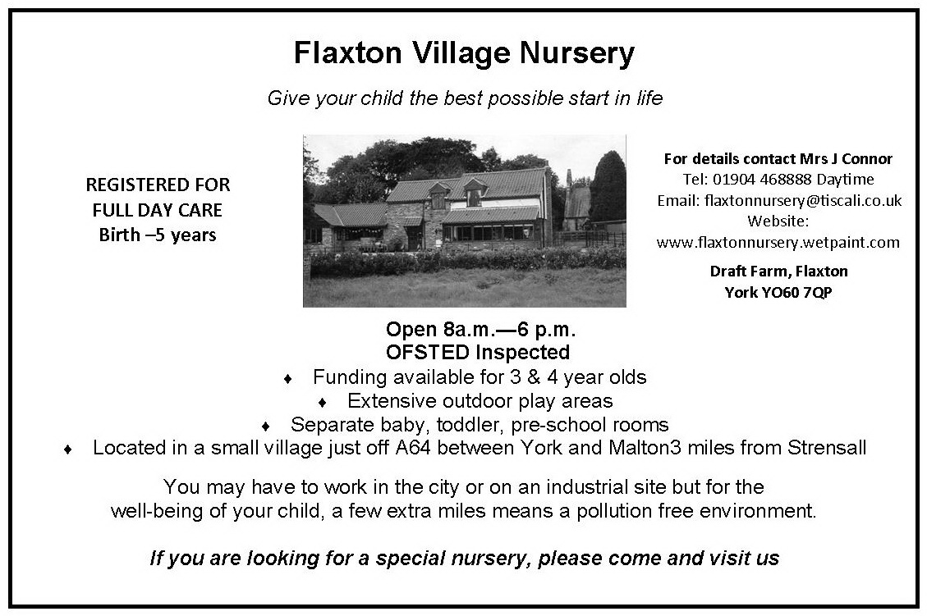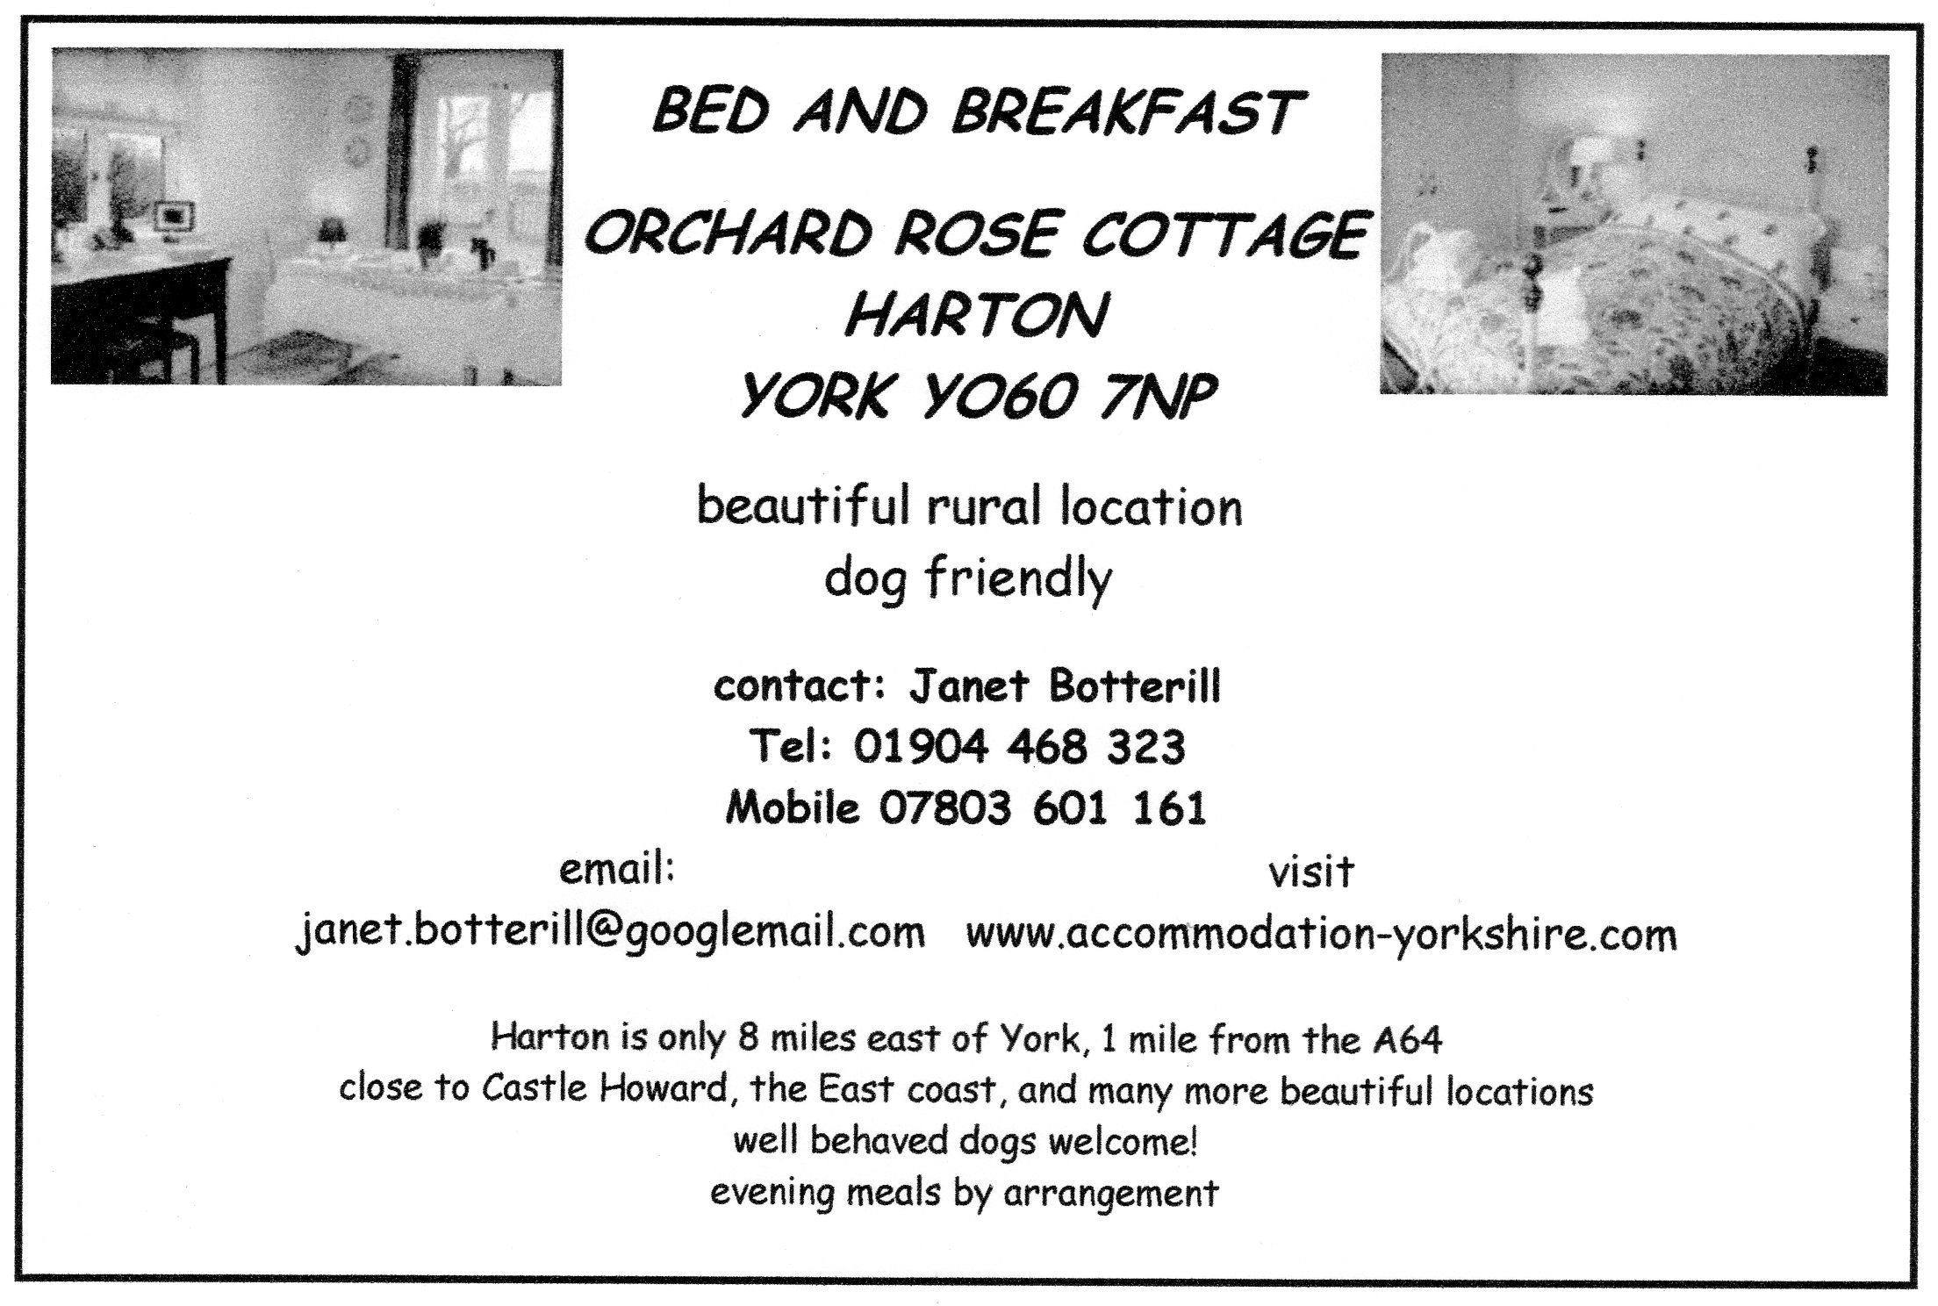
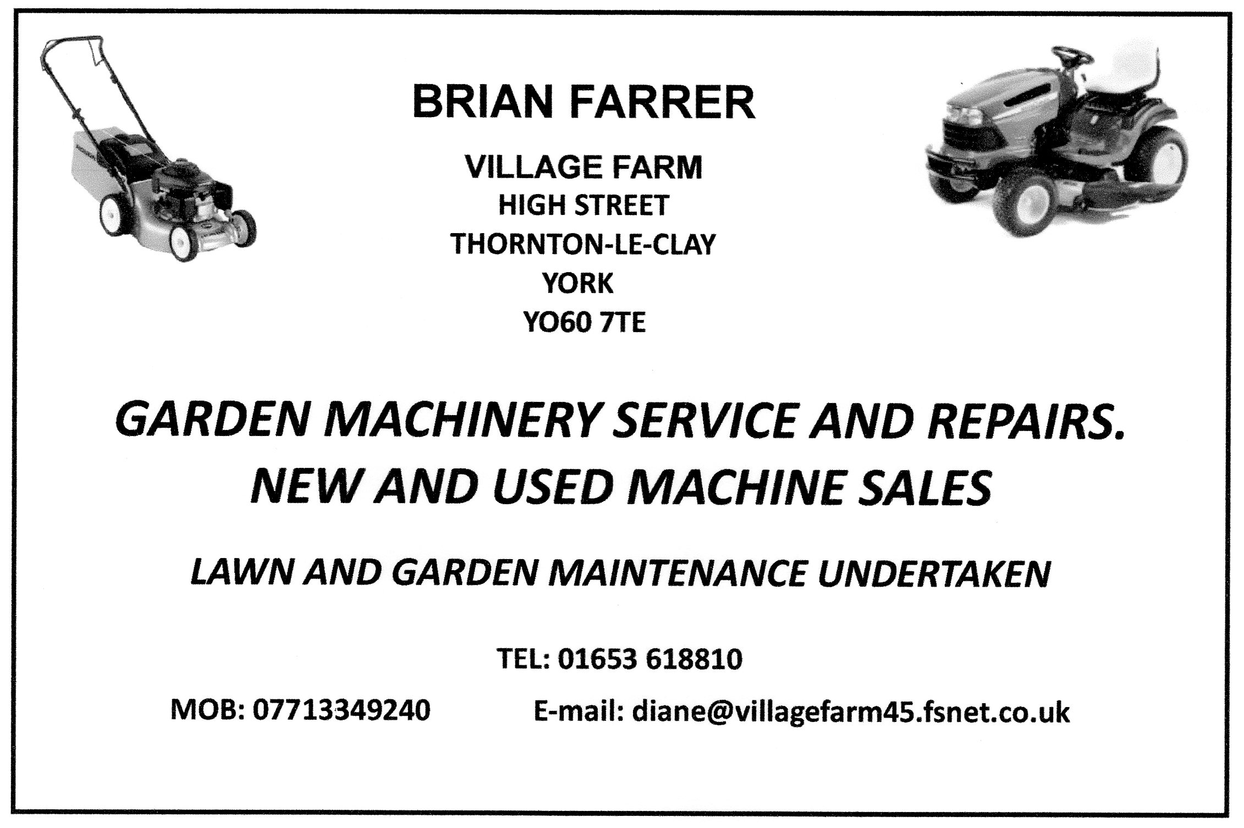

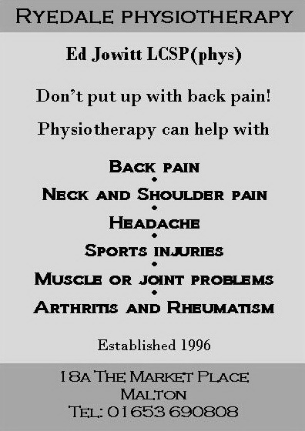
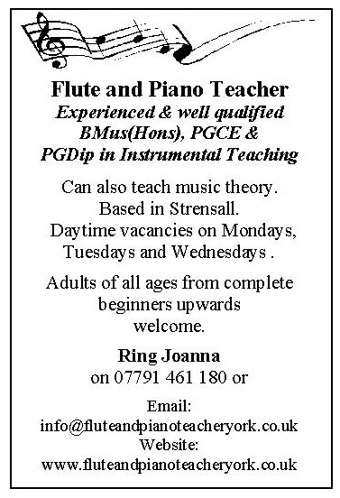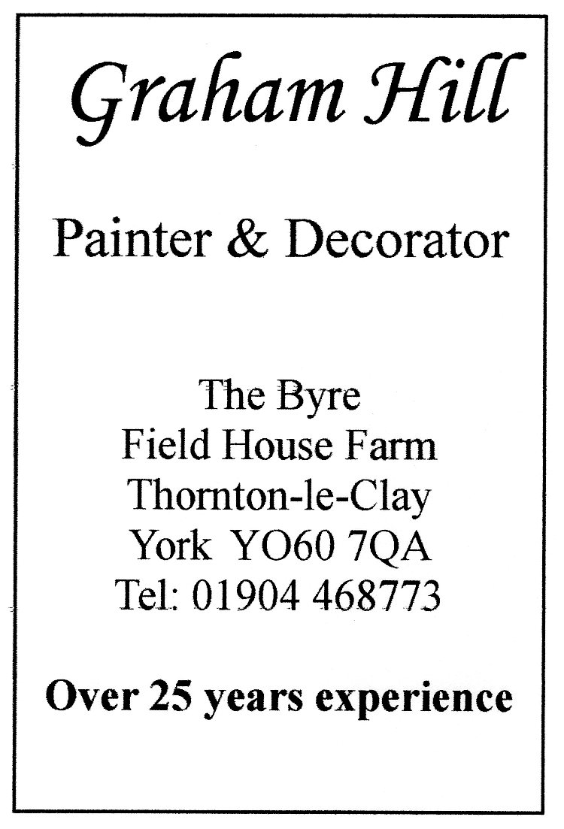

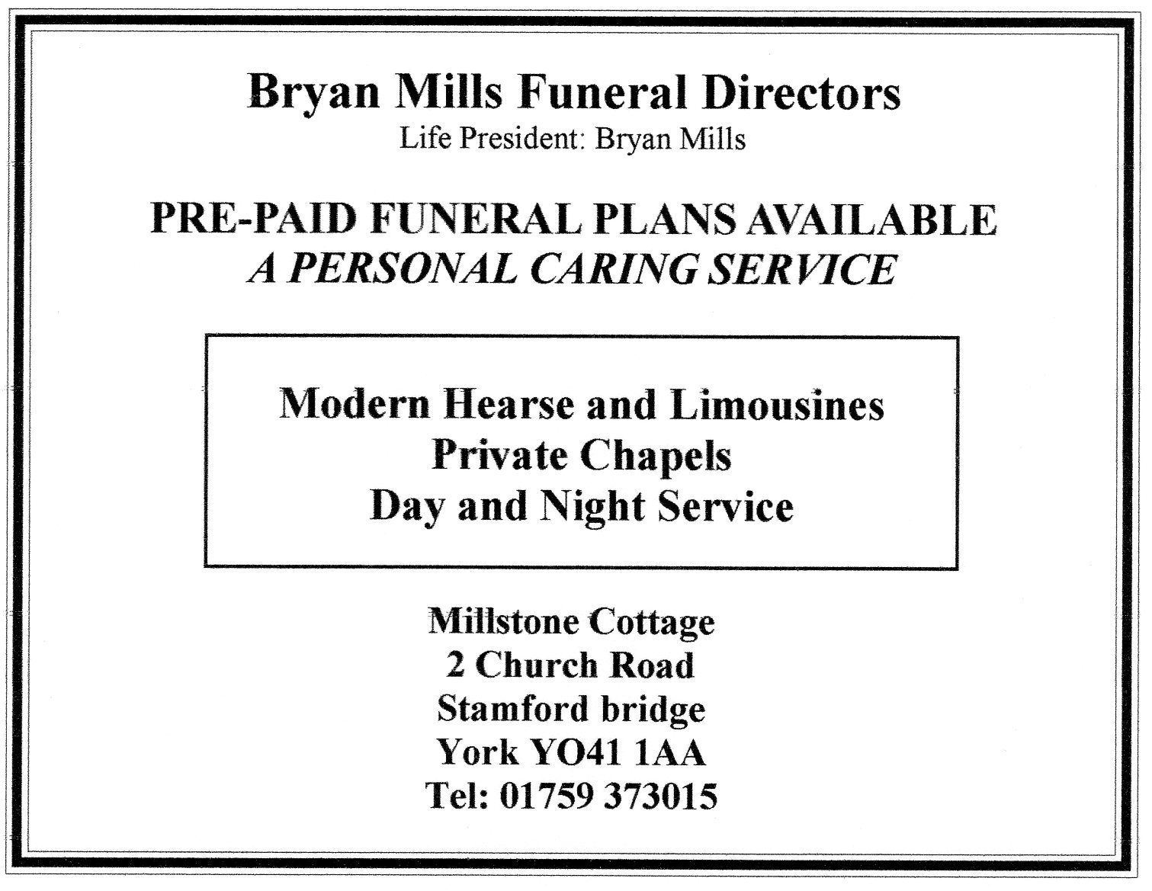

A thought for Easter
If the Christ who died had stopped at the cross,
His work had been incomplete.
If the Christ who was buried had stayed in the tomb,
He had only known defeat.
But the way of the cross never stops at the cross,
and the way of the tomb leads on
To victorious grace in the heavenly place
Where the risen Lord has gone.
Annie Johnson Flint

_____________________________________________________________
… and finally!
A young man who had just got his driving licence asked his father – a minister, if they could discuss the use of the car. His father took him to his study and said to him “I’ll make a deal with you. You bring your grades up, study your Bible a little - and get your hair cut and then we’ll talk about it.”
After a month the boy came back and again asked his father if they could discuss the use of the car. Again they went to the study where his father said, “Son, I’m proud of you. Your grades have improved, you’ve studied your Bible diligently – but you didn’t get your hair cut!”
“Well father” the young man said “I’ve been thinking about that. You know, Samson had long hair, Moses had long hair, Noah had long hair and even Jesus had long hair…”
To which his father replied, “Yes, and they walked everywhere they went!”

Items for ‘The Circular’

Copy deadline for the next edition April 17th 2014

This will cover May, June and July

Unfortunately it may not be possible to include
anything received after the deadline.

Contacts for The Harton Benefice during the Interregnum

Members of the Ministry Team are the first points of contact as follows:

Parish Sister: Sister Margaret Ann CSPH 01904 468253
Reader: Tony Hewitt 01904 632684
Lay Pastor: Rachel Baker 01904 468809

Also available for contact:
Lay Chairman, Joint PCC Delyth Harran 01759 372215

For specific issues to do with occasional offices contact should be made as follows:
Funerals Sister Margaret Ann CSPH 01904 468253
Marriages Rachel Baker 01904 468809
Baptisms Delyth Harran 01759 372215

For routine enquiries, The Rural Dean, Revd. Rachel Hirst, can be contacted through Delyth Harran, (or through the members of the Ministry Team).

Editor
Fiona Le Masurier
Crambe House, Crambe, York YO60 7JR
Tel: 01653 619368 email: churchmouse@yorlocal.com
Web address: www.sandhuttongroup.org.uk

Circular Printing Group members
Rachel Baker 01904 468809 Michael Harran 01759 372215
Peter Stott 01904 468404 Fiona Le Masurier 01653 619368
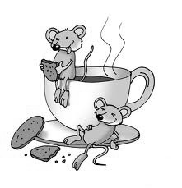

Watching that printer is thirsty work!

